Engineering Design Process Rubric

Definition of EDP: The engineering design process is the formulation of a plan to help an engineer build a product with a specified performance goal. This process involves a number of steps, and parts of the process may need to be repeated many times before production of a final product can begin.

Important elements of EDP:
- Correct terms are used
- Terms are connected to each other
- Terms are connected to each other in the correct order
- Cyclical Representation of EDP

The CEEMS project uses this graphical representation to explain EDP.

- Engineering Design Process (EDP):

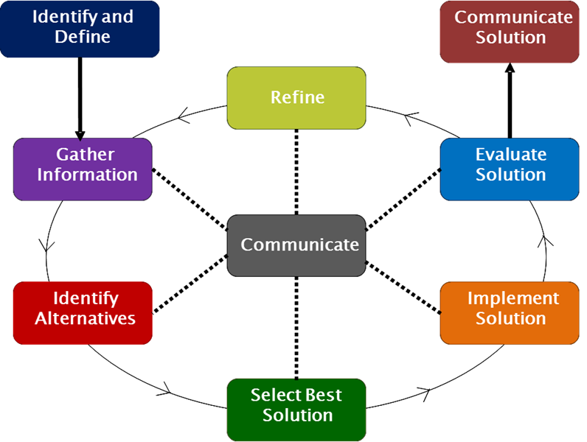

- EDP Activity: The Unit must include a culminating activity which models the complete EDP cycle and preferably include at least one refine cycle.

Directions given to the students as part of the CEEMS Student Feedback Survey:
In a drawing or diagram, arrange the following words in the order of the steps you just used in the engineering design process activity and connect each with an arrow, with the arrow-head pointing to the activity that will come next. You can use any of these words more than once, if needed.
- Identify and Define | - Evaluate or Test Solution(s) | - Refine
- Do Again | - Select Best Solution to Try | - Gather Information
- Communicate Solution(s) | - Identify Alternative(s) | - Implement Solution(s)

A sample of student drawings was evaluated using a rubric that included key elements of EDP (see table below).

Important elements of EDP:
- Correct terms are used
- Terms are connected to each other
- Cyclical Representation of EDP
- Terms are connected to each other in the correct order

Table 1: Scoring Guidelines for Student EDP drawings
0 | 1 | 2 | 3 | 4
Student has no relevant drawing  OR  Less than 6 terms written | Student uses at least 6 correct terms OR  Terms are connected to each other but not rewritten in the space (numbers or arrows or lines by the typed words) | Student uses at least 6 correct terms AND  Terms are connected to each other either by numbers or arrows or lines | Student uses at least 8 correct terms AND  Terms are connected to each other  AND  Cyclical with repetition (actually connected with arrows in circles; the words “do again” by themselves does not imply cyclical) | Student uses at least 8 correct terms AND  Terms are connected to each other  AND  Cyclical with repetition  AND  Terms are in the correct order (three acceptable orders are listed below and communicate can go in any spot; if other order is identified by a rater, it will be shared with others for confirmation of correctness.)
Comments: | Comments: | Comments: | Comments: | Comments:  ACCEPTABLE ORDER(s):  - Both “Identify and Define” and “Gather Information” need to be stated as 1 and 2 but the order does not matter.  - “Communicate” can be any where  - Middle items are “Identify Alternatives”, “Select Best Solution” and “Evaluate Solutions”  - 2 of the last three items need to include “Refine/Do Again”, “Implement Solutions” or “Evaluate Solution”

How did you act like an engineer?

Did they answer the question?
Look at WRITTEN comments only and identify the criteria it is related to.

ABET areas of skills
- an ability to apply knowledge of mathematics, science and engineering , (math, science, researched, measured)
- an ability to design and conduct experiments, as well as to analyze and interpret data (testing, measuring, compare)
- an ability to design a system, component, or process to meet desired needs within realistic constraints such as economic, environmental, social, political, ethical, health and safety, manufacturability, and sustainability (build or construct)
- an ability to function on multidisciplinary teams (we or our)
- an ability to identify, formulate, and solve engineering problems
- an understanding of professional and ethical responsibility
- an ability to communicate effectively (3g1 orally, 3g2 written) (presented, communicated,)
- the broad education necessary to understand the impact of engineering solutions in a global, economic, environmental, and societal context
- a recognition of the need for, and an ability to engage in life-long learning (their future education, course or career)
- a knowledge of contemporary issues (heart disease
- an ability to use the techniques, skills, and modern engineering tools necessary for engineering practice. (blueprint, surveyor)

What type of engineer did you act like?

Checklist Scale:
0 == No relevant answer (non-STEM)
1 == Specific engineering or STEM career skill or action
2 == Engineer or STEM field type identified BUT not an actual traditional engineering or STEM career
3 == Traditional engineering or STEM career

